iOS Developer Candidate Assignment

Make an iPhone app (written in Swift or Objective-C) that is exactly as shown in the screen shots below. It is a basic app that mimics functionality, which allows a user to keep track of the cars he/she has driven in and of the cars he/she still would like to drive in. For the data you will use two plist files, which are provided to you. Each of the plists contains an array.

We plan to discuss your project with you. In preparation for that:

* Please make a list with not more than five things that could be improved about your project
* Prepare to talk about design decisions you had to make while working on this app.

The app starts with a screen with just two buttons with text which are always centered on the screen:

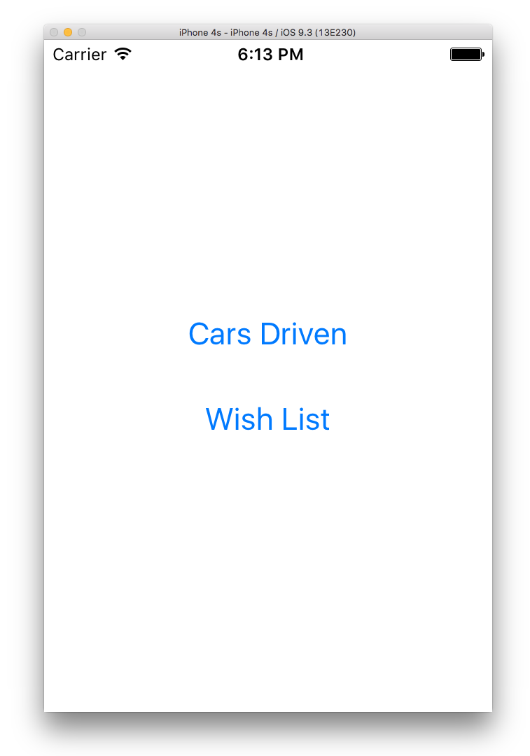

Tapping one of the buttons shows a table view:

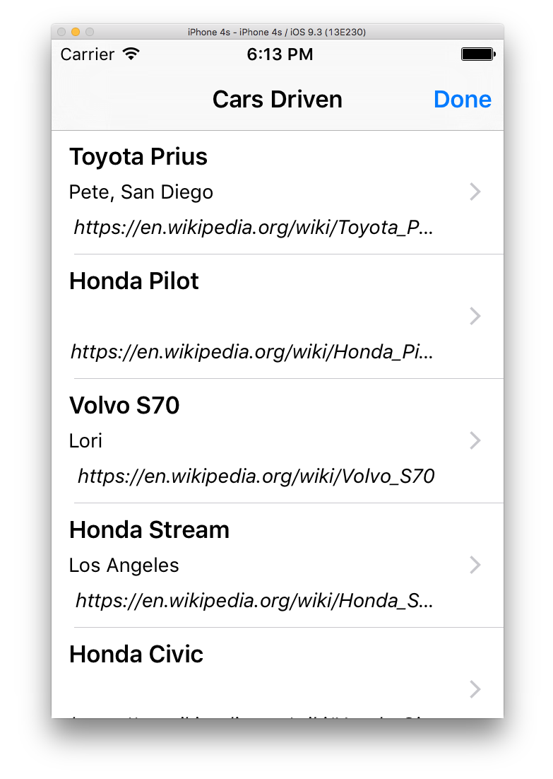

For each car there is a ‘Name’ and a URL. There may be some additional information also (owner and/or location).

The 'Done' button goes back to the main screen.

It also lays out nicely in landscape:

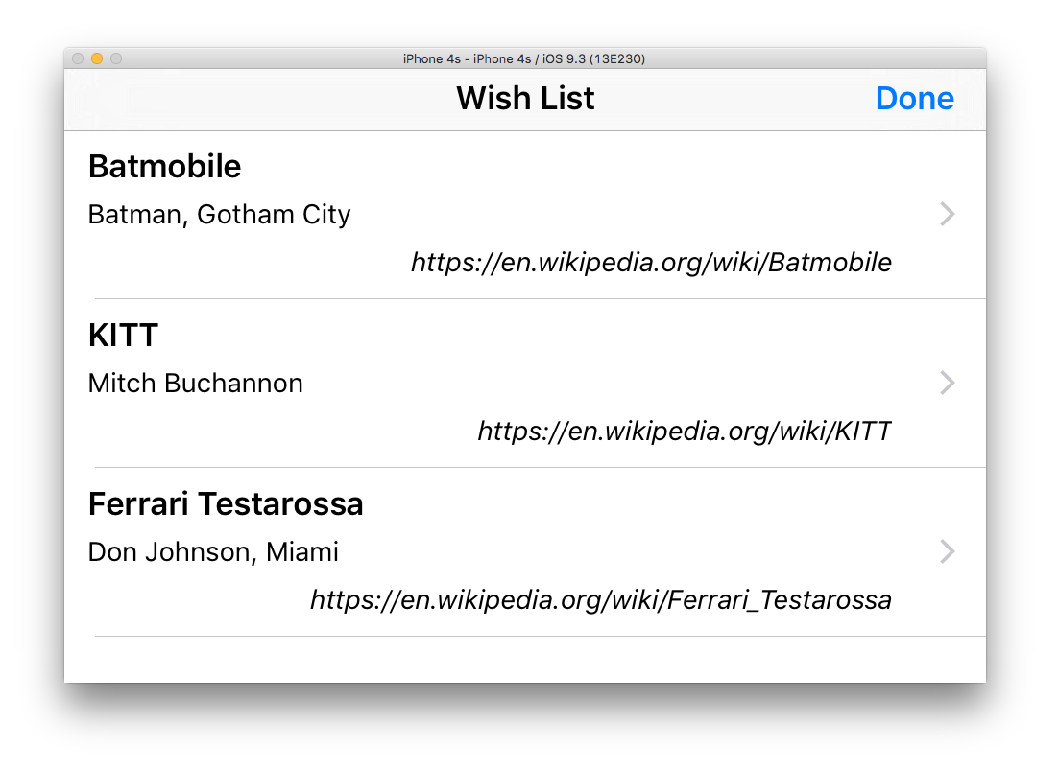

Going into detail shows a web view with the URL loaded:

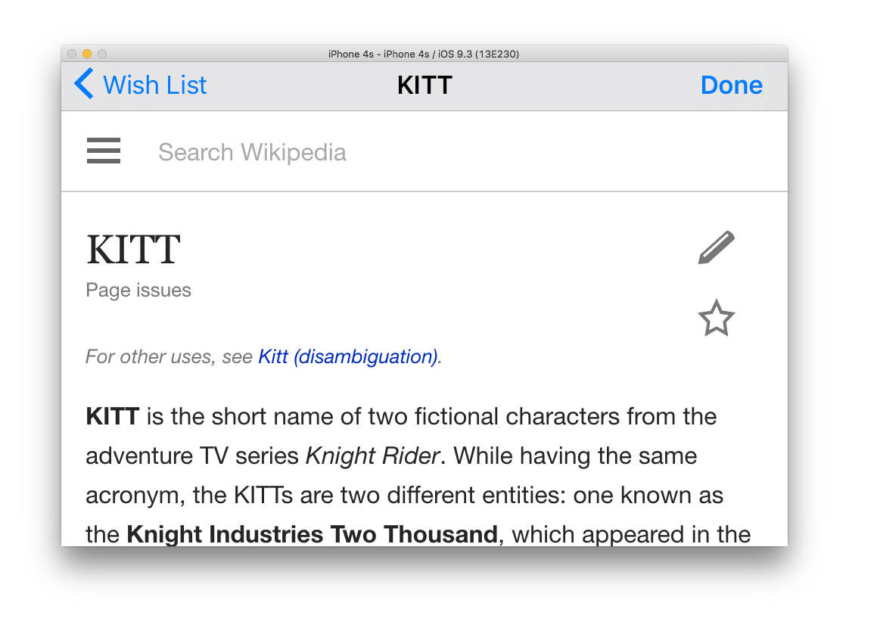

The 'Done' button goes back to the main (first screen) screen.

The first screen lists the last car ‘viewed in detail’ for each of the two lists:

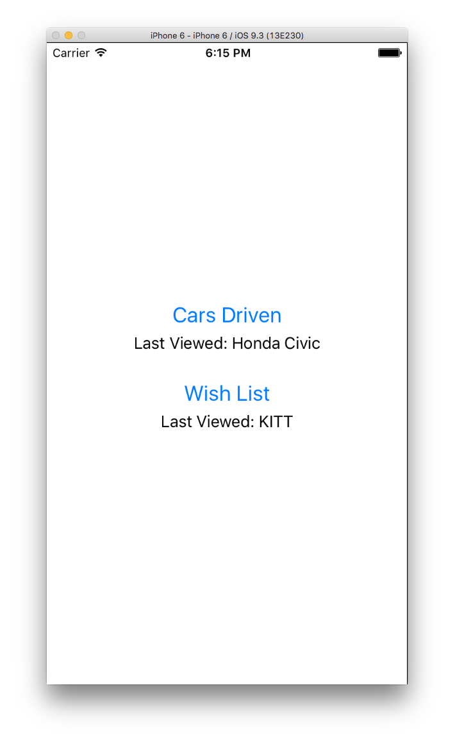

Some more screen shots while running on an iPhone 6:

